**Topic:** The Great Theorem, The Solution of the Cubic

**Notes on Topic:** Upon examining Chapter XI of *Ars Magna* the modern reader has two surprises

First, Cardano did not give a general proof, but a specific example, $x^{3}+6x=20$ (although we will look at the general equation, $x^{3}+mx=n$

Second, the proof was purely geometric and involved literal cubes and their volumes, but given the state of primitive symbolic algebra, and the “exalted position” of Greek geometry amongst the Renaissance mathematicians

The key result of Chapter XI is stated here, and although it may look quite confusing at a first glance, when looked at using an algebraic focus, it clearly does the job

In Cardano’s own words:

**Theorem:** Rule to solve $x^{3}+mx=n$

*Cube one-third the coefficient of X; add to it the square of one-half the constant of the equation; and take the square root of the whole. You will duplicate [repeat] this, and to one of the two you add one-half the number you have already squared and from the other you subtract one-half the same ... Then, subtracting the cube root of the first from the cube root of the second, the remainder which is left is the value of x.*

**Proof:** Cardano imagined a large cube, having side AC, whose length we shall denote by t, as shown in the figure. Sice AC is divided at B into segment BC of length u and segment AB of length t-u. Here t and u are serving as auxiliary variables whose values we must find. As the diagram suggests, the large cube can be sliced into six pieces, each of whose volumes we now determine

* A small cube in the lower front corner, with volume $u^{3}$
* A larger cube in the upper back corner, with volume ${(t-u)}^{3}$
* Two upright slabs, one facing front along AB and the other facing to the right along DE, each with dimensions (t-u) X u X t, thus each has volume $tu(t-u)$
* A tall block in the upper front corner, standing upon the small cube, with volume $u^{2}(t-u)$
* A flat block in the lower back corner, beneath the larger cube, with volume $u{(t-u)}^{2}$

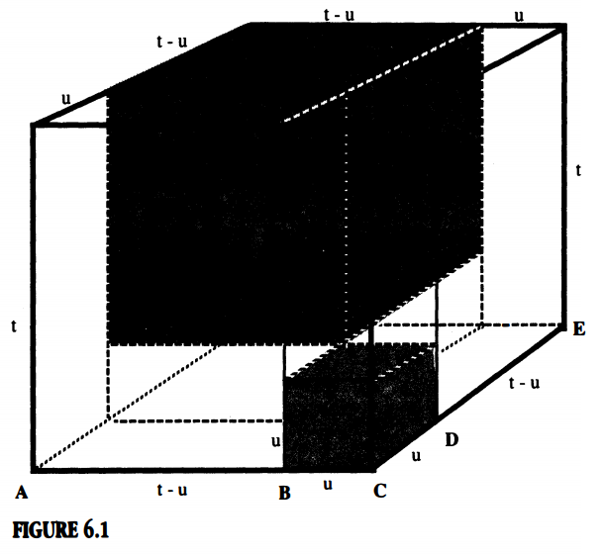

Clearly, the large cube’s volume is equal to the sum of the smaller volumes, so

$t^{3}=u^{3}+{(t-u)}^{3}+2tu(t-u)+u^{2}(t-u)+u{(t-u)}^{2}$

Some arrangements of these terms yields,

${(t-u)}^{3}+[2tu(t-u)+u^{2}(t-u)+u{(t-u)}^{2}]=t^{3}-u^{3}$

And factoring the common t-u from the bracketed expression gives,

${(t-u)}^{3}+(t-u)[2tu+u^{2}+u(t-u)]=t^{3}-u^{3}$, or simply

${(t-u)}^{3}+3tu(t-u)=t^{3}-u^{3}$ (*)

You will notice in (*) it is reminiscent of the original equation. If we let x=t-u it quickly becomes, $x^{3}+3tux=t^{3}-u^{3}$

Then, we set $3tu=m$ and $t^{3}-u^{3}=n$

*If we can now determine the values of t and u in terms of m and n, then we will have the solution we seek.*

First we are going to perform some algebra tricks and substitution on the equations above.

$3tu=m$ and $t^{3}-u^{3}=n$

From the former, we see that u = m/3t, and substituting this into the latter yields,

$t^{3}-\frac{m^{3}}{27t^{3}}=n$

Multiply both sides by $t^{3}$ and rearrange to achieve,

$t^{6}-nt^{3}-\frac{m^{3}}{27}=0$

This steps leaves us wondering, how is this an improvement. We seem to be digging ourselves deeper. But, really, this is a quadratic equation about the term $t^{3}$

${(t^{3})}^{2}-n(t^{3})-\frac{m^{3}}{27}=0$

The quadratic formula had been around for centuries, so we can now apply that formula to yield,

$t^{3}=\frac{n}{2}±\frac{1}{2}\sqrt{n^{2}+\frac{4m^{3}}{27}}=\frac{n}{2}±\sqrt{\frac{n^{2}}{4}+\frac{m^{3}}{27}}$

Then, using only the positive square root, we have,

$t=\sqrt[3]{\frac{n}{2}+\sqrt{\frac{n^{2}}{4}+\frac{m^{3}}{27}}}$

Now, we also know that $u^{3}=t^{3}-n$, and so we conclude that,

$u=\sqrt[3]{-\frac{n}{2}+\sqrt{\frac{n^{2}}{4}+\frac{m^{3}}{27}}}$

At last, we have the algebraic version of Cardano’s rule for solving the depressed cubic.

Yes, this proof got algebra heavy and somewhat convoluted, so I will sum up the final result.

**Final Result:** Given $x^{3}+mx=n$

$x=t-u$

$==\sqrt[3]{\frac{n}{2}+\sqrt{\frac{n^{2}}{4}+\frac{m^{3}}{27}}} -\sqrt[3]{-\frac{n}{2}+\sqrt{\frac{n^{2}}{4}+\frac{m^{3}}{27}}}$

**Q.E.D.**

This expression is called a solution by radicals.

This solution yields the same result as the verbal explanation Cardano gave above.

His genius approach was to minimize the cubic into a quadratic. He lowered his problem by one degree.

This process suggested a path to take in solving higher degree equations as well.

**A Concrete Example:**

Given $x^{3}+6x=20$.

Cardano’s Formula:

* Cube the third of the coefficient of x, ${(\frac{6}{3})}^{3}=8$
* Then square half of the constant term, ${(\frac{20}{2})}^{2}=100$
* Then added the two and took the square root, $\sqrt{108}$
* To this, he added and subtracted half of the constant term, $10+\sqrt{108}$ and $10-\sqrt{108}$
* Then the solution was the difference of the cube roots of these two terms above

You may have noticed, that the original equation we are solving for is a depressed cubic, Cardano said he was able to solve any cubic by transforming it into a depressed cubic.

But, how did he do this?

We must examine the “depressing” process for the cubic.

**Examining the Depressing Process for the Quadratic:**

The key substitution when depressing the cubic is: $x=y-\frac{b}{2a}$. Which yields,

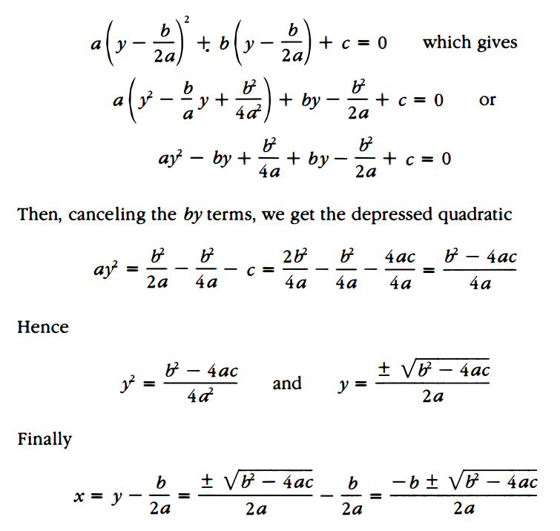

As modern readers, we know that there exist solutions to equations that involve square roots of negative numbers. Negative numbers were a hard concept to grasp in the 1500s, so imagine trying to grasp square roots of negative numbers.

Cardano examined these values and ultimately came to the conclusion that such values were “as subtle as it is useless”

Not until Rafael Bombelli in his 1574 treatise, *Algebra*, were imaginary or complex numbers examined. Rafael “took the bold step of regarding imaginary numbers as a necessary vehicle that would transport the mathematician from the real cubic equations to its real solutions”

**Additional Suggested Reading**: Read the process for depressing the cubic, Bombelli’s argument regarding the square root of negative 1, Epilogue Chapter 6

**Assignment:** Homework Problem 78, 80, 85, 89